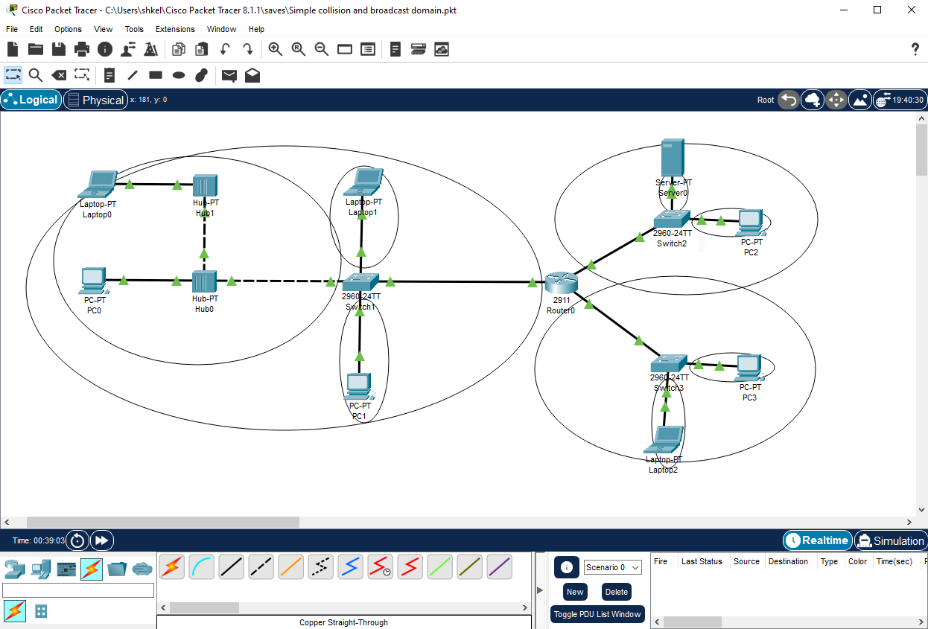Simple collision and broadcast domain using Cisco Packet Tracer

Broadcast domains

Collision domains